Quadratic function (Funkcja kwadratowa)
Definition of quadratic function
If a, b and c are real numbers, and a≠0, the function f(x)=${ax}^{2}$+bx + c is a quadratic function.
f(x)=${ax}^{2}$+bx + c is the general form.
The graph of f is the graph of the equation y=${ax}^{2}$+bx + c and is called a parabola.
Examples of quadratic function:
- f(x) =${-x}^{2}$+3x + 2 (where a=-1, b=3, c=2)
- f(x) =${4x}^{2}$-0,5x (where a=-4, b=-0,5, c=0)
- f(x) =$x^{2}$ (where a=1, b=0, c=0)
- f(x) =${21x}^{2}$+$\sqrt{15}$ (where a=21, b=0, c=$\sqrt{15}$)

If a>0 then the parabola opens upward
If a<0 then the parabola opens downwards

Each parabola is symmetric about a vertical line called its axis of symmetry, The axis of symmetry passes through a point on the parabola called the vertex of the parabola.
If the leading coefficient, a, of the quadratic function f(x)=${ax}^{2}$+bx + c is positive, the parabola opens upwards (concave up) – and the y-coordinate of the vertex will be a minimum value for the function.
If the leading coefficient, a, of the quadratic function f(x)=${ax}^{2}$+bx + c is negative, the parabola opens downwards (concave down) – and the y-coordinate of the vertex will be a maximum value for the function.

Rys.- Przykłady wykresów funkcji kwadratowej.

Axis of symmetry
This occurs at x=$\frac{-b}{2a}$

Vertex (turning point)
W($\frac{-b}{2a}$; f($\frac{-b}{2a}$))

Exercises.

Exercise 1.
For the quadratic function f, find
- the equation of the axis of symmetry
- the coordinates of the vertex
- f(x)=${4x}^{2}$-2x + 1
- f(x)=${-0,5x}^{2}$+3x
- f(x)=$x^{2}$
- f(x)=${12x}^{2}$-5

Vertex form of a quadratic function (turning point form of a quadratic function)
f(x) = a${(x-p)}^{2}+q$ where a≠0, p=$\frac{-b}{2a}$ ; q=$\frac{-∆}{4a}$ and $∆=b^{2}-4ac$

If a quadratic function is written in the form f(x) = a${(x-p)}^{2}+q$, with a≠0, the graph of f has an axis of symmetry of x=p and the vertex at (p,q).
Exercise 2.
Express the following functions in turning point form.
- y = $x^{2}$-2x + 1
- y = $x^{2}$+4x
- y = $x^{2}$+ 4
- y = ${-x}^{2}$-2x + 2
- y = $-x^{2}$-6x
- y = ${-0,5x}^{2}$ +3
Sketching the graph of a quadratic function
Method – the turning-point form
i.e., expressing f(x) = $ax^{2}$+bx+c, a≠0 in the form f(x) = a${(x-p)}^{2}+$q.
This involes
Step 1. Expressing f(x) = $ax^{2}$+bx+c, a≠0 in the form f(x) = a${(x-p)}^{2}+$q.
Step 2. Use the turning point (p,q)
Step 3. Finding the axis of symmetry x=p
Step 4. Finding the y-intercept (finding f(0)
Step 5. Sketch the parabola
Exercise 3.
Express the following functions in turning point form and hence sketch their graphs.
- y = $x^{2}$-2x + 1
- y = $x^{2}$+4x
- y = $x^{2}$+ 4
- y = ${-x}^{2}$-2x + 2
- y = $-x^{2}$-6x
- y = ${-0,5x}^{2}$ +3

Exercise 4.
Find the equation of the quadratic function with graph

The Discriminant
The expression $b^{2}-4ac$ is known as the discriminant and often represented by the delta symbol $∆=b^{2}-4ac$

Geometrical Interpretation and The Discriminant
The number of x- intercepts for the function f(x) = $ax^{2}$+bx+c, a≠0 = the number of solutions to the equations to the equation $ax^{2}$+bx+c = 0, a≠0

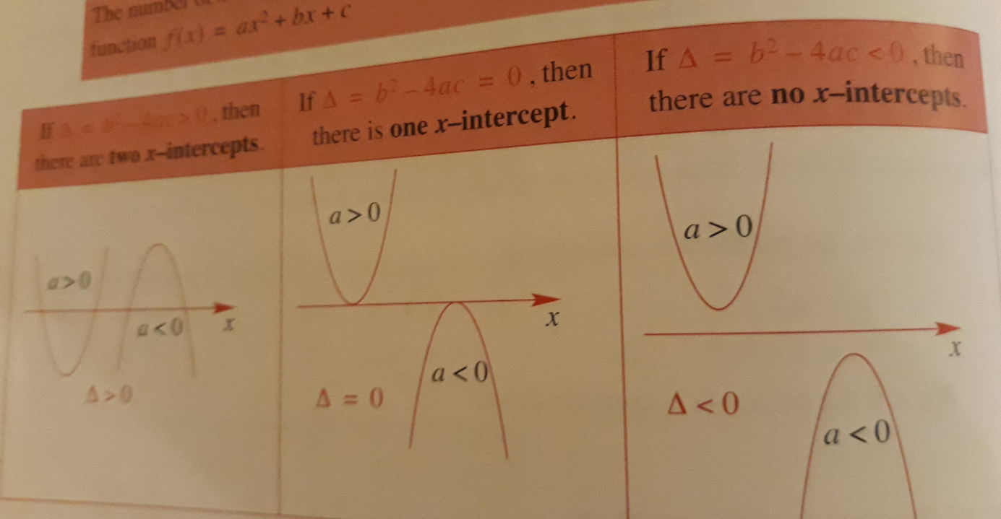
Factorized form of a quadratic function
If a quadratic function is written in the form f(x) = a(x - $x_{1}$)(x-$x_{2}$), with a ≠0 the graph of f has x-intercepts at ($x_{1}$,0) and ($x_{2},0).$

Exercise.
Find the equation of each quadratic function from the graph in the form f(x) = a(x - $x_{1}$)(x-$x_{2}$) and also in the form f(x) = $ax^{2}$+bx+c
a)
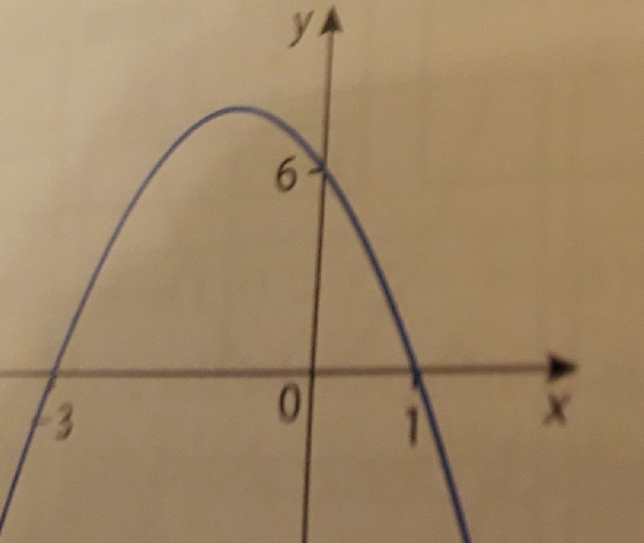

Zadania różne

The graph of a quadratic function intersects the x-axis at the points (-5,0) and (2,0) and also passes through the point (1,-3).
- Write the function in the form f(x) = a(x - $x_{1}$)(x-$x_{2}$)
- Find the vertex of the parabola
- Write the function in the vertex form of quadratic function

Exercise.

For what value(s) of k will the function f(x) = $x^{2}$+4x+k
- cut the x-axis twice
- touch the x-axis
- have no x-intercepts
Exercise.
A quadratic equation in the variable x (say) takes on the form $ax^{2}$+bx+c= 0 where a, b and c are real constants.
Tabela duza strona 48
Discrimiant | Number of solutions $ax^{2}$+bx +c = 0
$∆$ >0 | Can be factorized to obtain 2 real and unique solutions.
$∆$ =0 | Can be factorized to obtain 1 real (repeated) solution.
$∆$ <0 | Cannot be factorized and so no real solutions exist.

Exercise.
Solve these equations
- ${-x}^{2}$-2x -1 = 0
- $x^{2}$-12x + 20 = 0
- ${-5x}^{2}$-2x – 2 =0
Exercise.
Write a quadratic equation in x with solutions of -1 and 2/3.

Exercise
Find two numbers whose sum is 17 and whose product is 66.
Exercise.
Solve ${6x}^{2}$-17x + 12 =0 and show that the sum of the two solutions is 17/6 and the product of this solutions is 2.
Exercise.
Find the values of k for which the quadratic ${2x}^{2}+kx+9$ = 0 has
- one real solution
- two real solutions
- no real solutions

Exercise.
Prove that the equation ${kx}^{2}+3x-k$ = 0 has two real solutions for all non-zero real values of k.

